**Fluid Dynamics (basics)**

* For simplicity sake we will keep our frame of reference on the craft. This way, it looks like the air is moving and the craft is stationary which makes it easier to visualize.
* **Thrust** – The propulsive force produced by an engine exerted on a craft.

Why fluids are so important:

All planes require a medium to move through and would be useless in a vacuum. The idea is that if you want to change your liner velocity, you have to push of something and leave it behind which is why spacecraft require a fuel that it throws out for thrust. In the case of a plan (aircraft) it doesn’t need to throw out its fuel for thrust, instead it can push off the air. If a plane did not use a fluid to move, it would be highly inefficient. The fluid can also be used to perform maneuvers that would make the plane more useful. A fluid is a medium in which particles that make it up are free to move.

Even in under water life and aves, most creatures use the medium to push themselves.

* All resistive forces produced by the fluid exerted on the craft is called 'drag'. Drag can be takes advantage of by control surfaces to maneuvers the plane or even slow it down.

**Lift**:

* force that caries a plane upwards and keeps it there.
* to simplify the explanation, use of Bernoulli’s equation has been omitted

You may often hear or understand only half of the explanation for how a plane can generate lift.

To understand why lets explore a few ideas:

**1.** Moving air creates an area of low pressure (known as Bernoulli’s effect). This may not be very intuitive but it can be demonstrated; If you were to blow on the side of a candle using an object to prevent air from moving directly towards the frame, you will notice that the flame will bend towards the moving stream of air. Or you will notice that if a visible vapour or smoke is in a moving car and the window is slightly open whereas not to disturb the airflow, the smoke or vapour will start moving towards the stream of air outside the car.

**2**. Air moves faster around a curved surface and tends to trace it (move along the surface). The diagram illustrates how air would move around a ball compared to a box with no curved surface:

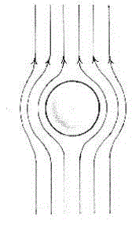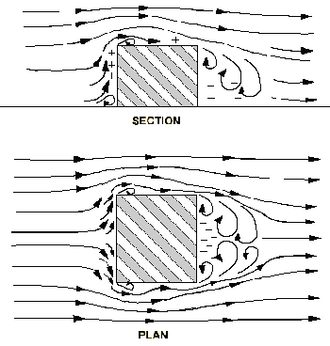

* Notice how for the box, when ever the air passes a flat surface over an edge, it curves backwards, this is known as turbulent air flow.

**3.**Things move from high pressure to low pressure, you can see this when you drink from a straw; as you suck the air out of the straw you create an area of low pressure and the liquid then tries to fill it's place allowing you to drink it.

**4.** Drag is a type of frictional force. All this means is that it opposes the motion of the plane the same way in which friction between the road and a car would stop a car when it brakes.

* If you think about it, the dynamics of flying are fundamentally similar to driving, because while driving you are pushing of the road and while flying you are pushing of the air.
* Back to lift: observe the air flow diagram of the cross-sectional area of a flat wing;

* 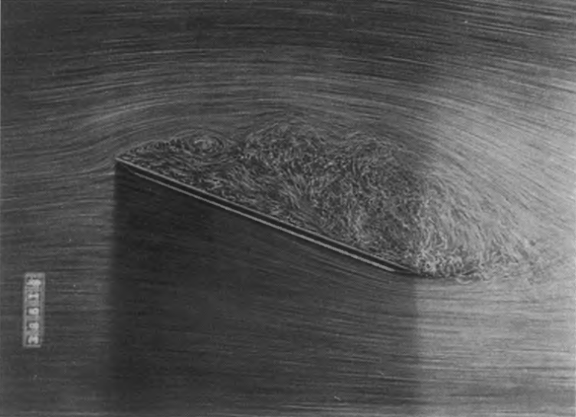Angle of attack – angle at which the wing is oriented relative to the direction of moving air.
* You will already notice the first force at play which occurs the bottom of the wing. When the air hits the bottom, it produces an upwards force. This force is dependent on the angle of attack

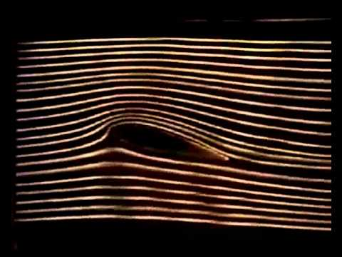But this is only half the explanation for modern planes because there is a more efficient way in which we can have lift:

Observe the airflow diagram of the cross sectional area of the following wing:

* First notice that the top surface is significantly more curved than the bottom surface.
* This wing also uses the force mentioned above but there is another force at play.

Because the top surface is more curved than the bottom, air moves significantly faster over it. This creates an area of lower pressure then the bottom which also assists in lift.

Also note that the air flow at the bottom is laminar (regular) while the airflow on the top is turbulent(irregular and turns back on its self)